GSorting： An application that helps users to sort and dispose of garbage.

Congying Zhang#1

Seidenberg School of Computer Science and Information Systems *Pace University, New York, NY, USA*

2cz80604p@pace.edu

***Abstract - This paper explores the importance of waste management in building sustainable cities and communities. In modern society, a large amount of waste is generated rapidly in people's lives and various industries, and too much waste creates a significant burden on the environment. However, through proper waste separation and disposal, it is possible to reduce the amount of waste disposal, lower the cost of disposal, reduce the consumption of land resources used for landfill waste, reduce the environmental hazards of hazardous waste, and also allow many resources to be reused. Many people cannot properly dispose of their garbage because they cannot accurately sort it in their busy lives.***

***This paper proposes a text search and object recognition technology solution to create an automated garbage search system. This system can classify this item by the item's name or by recognizing the item in the picture so that the user can dump the garbage correctly in various bins. Implementing this system can improve the efficiency of garbage sorting and disposal efficiency, thus effectively helping society deal with public garbage hazards.***

***The keywords： picture recognition, image classification, text recognition, waste classification, waste management, etc.***

1. Introduction

Separation of waste is the best solution and the best way to deal with the waste public hazard. Separation of waste has become the inevitable path for developing a country. According to a 2018 World Bank report: driven by rapid urbanization and population growth, the annual amount of waste produced globally is expected to increase by 70% in the next 30 years.[3] Among the many factors driving waste growth, urbanization, and population growth are two of the main ones. With global urbanization on the rise, according to U.S. demographics, the U.S. urban population is currently up to 83% of the total population.[6] This figure continues to rise, expected to reach 87% in 2050, so the U.S. solid waste (also known as garbage) production reaches 268 million tons per person per year, the highest in the world, but the recycling rate is only 35%.[7] Garbage recycling has become a severe problem that American society must face.

The primary method of disposal for most waste is landfill, which is inefficient in explaining, and the waste that is landfilled produces urban waste leachate, which has a large amount of toxic and harmful substances as well as various pathogenic bacteria that seriously pollute the soil, the surrounding environment, and groundwater resources.[2]

However, if the waste is sorted, there are different results: recyclable waste, such as plastic and paper, are sorted according to their material and packed together, and then they are transformed into new materials; kitchen waste can be transformed into fertilizer or used for biogas generation; dry waste and some hazardous waste can be incinerated, which avoids contaminating the soil. To achieve waste separation, using a mobile app can help city residents quickly separate and properly discard their waste, to help society recycle and dispose of household waste more efficiently.

The Gsorting app uses two main ways to help identify the type of garbage: the first is that the user takes a picture to the phone and then uploads the picture to allow the app to identify the items within the picture based on the picture and then retrieve the classification (That will be upgraded in sprint2 by accessing AWS and other implementations). The second one is to search the item name to find the corresponding garbage type in the database and display it to the user. These two parts will be discussed in detail in the subsequent chapters. (The rest of the parts will be done in sprint 2.)

II. LITERATURE REVIEW

Image classification systems for recyclable waste based on machine learning and image classification recognition are a hot topic. Machine learning provides powerful support for all aspects of modern machinery, especially in the field of machine vision. It is the latest area of ongoing research where algorithms help computers understand and classify digital images in the same way as humans. Machine learning allows machines to perform repetitive sorting tasks more efficiently than humans. One such problem, garbage sorting, has attracted widespread community attention. The main goal is to design a system based on machine vision techniques to accurately and automatically identify the type of garbage. The following paper will review the recent research progress in machine learning-based garbage sorting systems.

First, traditional machine learning-based garbage classification systems usually use image processing and feature extraction techniques to convert garbage images into mathematical feature vectors and then use classifiers to classify them. Popular traditional ML algorithms used in previous studies include linear discriminant analysis (LDA), nearest neighbor (NN), decision tree (DT), Bayesian networks, artificial neural networks (ANN), support vector machines (SVM), and rule-based classifiers.[3] These models are usually simple in structure and cannot automatically extract high-level representations from the original images; thus, they require manually designed features such as HOGs and intensity histograms, and traditional methods usually require manual classifier selection and training, which can lead to classifier performance limited by the quality of the features and require significant manual involvement. For example, in 2016, Thung and Yang built two classification models using SVM and CNN on the TrashNet dataset, and the experimental results showed that the SVM model had an accuracy of 63% for spam classification; however, the CNN model performed poorly with an accuracy of only 22%.

To solve this problem, the application of deep learning in garbage classification has emerged in recent years. Deep learning harnesses the power of big data through its deep structure to achieve what is known as "end-to-end" training. Deep learning learns features in the data and can automatically perform feature extraction and classification. In a typical DL architecture, rather than handcrafted features, the original raw image is fed directly to a network of multiple convolutional, pooling, and fully-connected layers, which automatically learn and extract hidden features from the image, which are then used to predict category labels.[4] The end-to-end learning mechanism avoids the tiresome process of feature handcrafting and thus greatly expands the applicability of CV-enabled waste sorting.[4]

Moreover, since the dataset contains a wide range of waste samples, the resulting DL models tend to be more robust than those trained using traditional ML algorithms. For example, in 2017, Chollet proposed Xception based on Inception and deep separable convolution. Deep separable convolution improves the efficiency of convolutional operations and reduces the FLOPs of convolutional layers and parameters. Thus, while maintaining the same complexity, Xception uses deep separable convolution to design a more complex network structure and its ImageNet dataset with better accuracy than Inception v3. However, the model's complex branching structure and the computational process's fragmentation lead to computational inefficiency.

Another solution in recent years is to integrate CNN with traditional machine learning algorithms, using CNN only for feature extraction, while traditional machine learning models perform classification. CNN excels at learning features through its deep network, while SVM is a traditional ML algorithm that is a powerful classification tool.[3] By combining the two, higher performance can be obtained. For example, Adedeji and Wang used this technique to extract features learned by ResNet-50 and use SVM for garbage classification, and this model achieved an accuracy of 87%.[1] Moreover, the combined use of these two models can easily integrate deep features extracted by different networks, for example, in the integrated model of Toğaçar et al. with an impressive accuracy of 99.95%.[4]

To sum up, considering the existing research analysis: including all the results and considerations, Gsorting aims to be an app that can recognize more kinds of objects using Keras Sequential Neural Network (KSNN) to help classify garbage faster.(This idea is based on the professor's excellent examples, and the specific implementation will be adjusted in sprint 2）

III. CURRENT SOLUTIONS

Many types of waste management applications on the market use technologies such as machine learning to identify and sort household waste and mechanically classify it into two broad categories, recyclable and non-recyclable. They effectively reduce the human investment in waste sorting and reduce the chance of waste sorters getting sick (much of the waste is toxic, and those involved in manual waste sorting are susceptible to illness).

The efficiency of waste management applications depends on the accuracy of the models, which is achieved through excellent model building and proper training. Some better-known applications or companies are Bin-e, Ecube Labs, and Rubicon Global. These applications use various technologies to help users sort and recycle waste, each with its characteristics, encouraging people to sort and recycle waste. Each app has different features encouraging people to separate their waste and work towards ending it.

Bin-e is an intelligent waste management system that uses machine learning to sort recyclable and non-recyclable waste. The system consists of an intelligent bin equipped with sensors and cameras and a cloud platform that processes the data collected by the garbage can. Its company was founded in 2015 to develop a system that would help solve the growing waste management problem and improve the efficiency and accuracy of waste sorting. bin-e offers many features, making it a unique and effective waste management solution. First, the system uses machine learning algorithms to identify and sort different types of waste. Sensors and cameras in the bins capture images and data, which are then analyzed by the platform to determine the waste type and sort accordingly. Users no longer need to sort their trash, they can just drop it in, and it will automatically sort and sort itself and automatically compress plastic and paper. Second, Bin-e is designed to be user-friendly and customizable. Users can configure the system to meet the specific needs of different locations and waste management programs. Finally, Bin-e provides real-time data and analytics that can be used to optimize waste management processes. The platform provides detailed reports on waste volumes, recycling rates, and other key metrics to help users decide on waste management strategies and resource allocation. Below is an image of the Bin-e trash can.

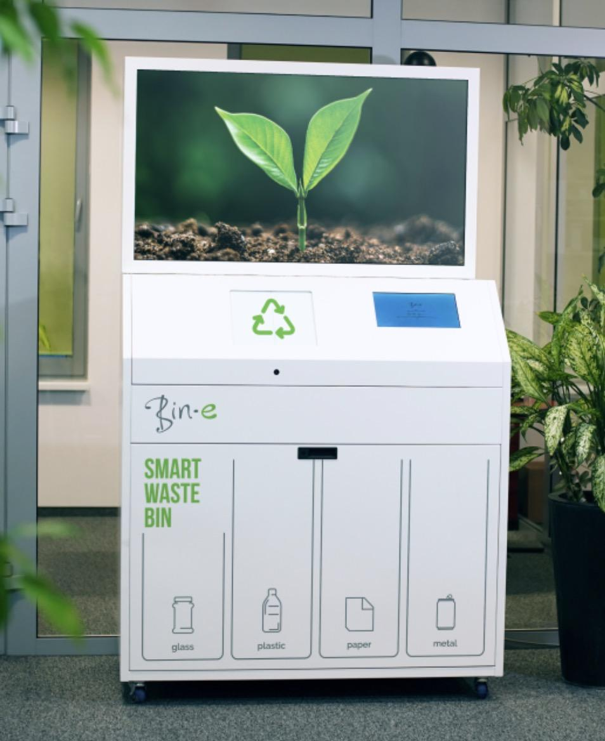

Fig. 1 The image of the Bin-e trash can

CleanCityNetworks is a mobile application from eCube Labs designed to help users better manage and dispose of their waste. The app offers a variety of valuable features and tools to facilitate access and management of waste management data anytime, anywhere. By using the company's Bin Alive and other tools, coupled with CleanCityNetworks, users can access and monitor the capacity and fill of their bins or carts in real-time through the app, optimizing collection routes, checking battery levels, geolocation, collection history, overflow status, response times, and so on. for timely action. The app can also identify the type and quality of waste and provide information and advice on waste sorting and recycling for better waste management. Some of the images to the west are the functional interface of this application.

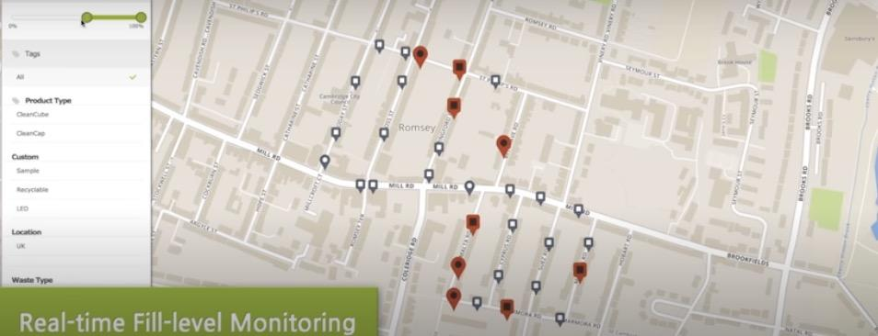

Fig. 2 the images to the west are the functional interface of this application

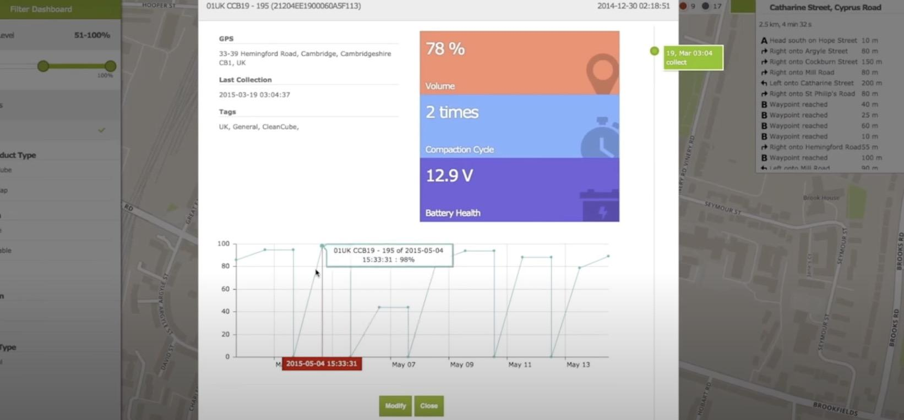

Fig. 3 the images to the west are the functional interface of this application

RubiconSmart app is developed by Rubicon using modern technology tools such as IoT technology, big data analytics, and artificial intelligence to develop a set of intelligent waste management that can help businesses and governments to better manage and dispose of waste.

Rubicon's Smart Waste Management platform has the following key features and benefits.

Smart sensors: Rubicon's smart sensors can be installed on waste bins or garbage trucks to monitor the capacity and filling of waste in real time for better waste collection and disposal schedules.

Big Data Analytics: Rubicon's platform enables real-time analysis and processing of data collected by sensors to optimize waste collection and disposal, reducing costs and increasing efficiency.

Artificial intelligence technology: Rubicon's platform can also employ artificial intelligence technology to sort and identify waste for better recycling and reuse.

Mobile app: Rubicon's mobile app allows users to access and manage waste management data, including waste capacity, collection schedules, fees, and other aspects, anytime, anywhere.

RubiconSmart can help enable a more efficient, intelligent, and sustainable approach to waste management. At the same time, Rubicon can help reduce the cost of waste disposal, improve resource efficiency, and reduce environmental pollution and damage from waste.

IV. PRODUCT REQUIREMENTS

The Gsorting project aims to develop an application designed to help users quickly sort their household waste and give recommendations for disposal. The application uses text search, image recognition, and machine learning algorithms (to be added in sprint2) to identify household waste from familiar places such as homes, meeting places, and schools, enabling users to quickly distinguish the type of waste and provide appropriate disposal advice.

Gsorting makes garbage disposal easier and faster. In order to make this application easier to use and fulfill the development purpose, it needs to have some key features as follows：

1) Take photos: - For ease of use, users should be able to take photos directly from within the app instead of only being able to upload images.

2) Text search: - Provide users with the ability to search for text when they cannot use the camera or pictures.

3) Trash detection:- The application should have the ability to identify and classify trash into the following categories: recyclable trash, dry trash, wet trash, and hazardous trash.

3) Information Retrieval: The application should be able to retrieve data from the garbage classification and provide practical suggestions to the user.

4) Multiple identifications: The user should also be able to send a picture of the garbage, let the application segment, and classify all the garbage items in the picture.

5) User database: The application should be able to create a personal database for the user to store and analyze household trash data.

V. Methodology

User Front End

I chose to use the Android mobile application as the user front-end because it would allow us to provide more built-in functionality to the user and optimize the UI as much as possible to enhance the user experience and make it easier to the user to use the app. Gsorting application was built on Android Studio, and the language used was JAVA.

（The next sections will be added in Sprint 2 for completeness）

VIII. REFERENCES

[1]Adedeji, O., & Wang, Z. (2019). Intelligent Waste Classification System Using Deep Learning Convolutional Neural Network. Procedia Manufacturing, 35, Pages 607–612. https://doi.org/https://doi.org/10.1016/j.promfg.2019.05.086.

[2] Cifani, S. (2023, February 17). What Happens to Trash After It’s Tossed? Dumpsters.Com. <https://www.dumpsters.com/blog/what-happens-to-garbage>

[3] Global Waste to Grow by 70 Percent by 2050 Unless Urgent Action Is Taken: World Bank Report. (2018, September 20). The World Bank. https://www.worldbank.org/en/news/press-release/2018/09/20/global-waste-to-grow-by-70-percent-by-2050-unless-urgent-action-is-taken-world-bank-report

[4]Lu, W., & Chen, J. (2022). Computer Vision for Solid Waste Sorting: A Critical Review of Academic Research. Waste Management, 142, Pages 29–43,. https://doi.org/https://doi.org/10.1016/j.wasman.2022.02.009

[5]Mookkaiah, S.S., Thangavelu, G., Hebbar, R. et al. Design and development of smart Internet of Things–based solid waste management system using computer vision. Environ Sci Pollut Res 29, 64871–64885 (2022). https://doi.org/10.1007/s11356-022-20428-2

[6]O’neill, A. (2022, November 10). Degree of Urbanization in the United States from 1790 to 2020, and with Projections until 2050. Statista.Com. https://www.statista.com/statistics/269967/urbanization-in-the-united-states/

[7]Turrentine, J. (2019, July 12). The United States Is the Most Wasteful Country In the World. Nrdc.Org. https://www.nrdc.org/onearth/united-states-most-wasteful-country-world

[8]